Subject line: 20% off registration fees for FIGO 2021!

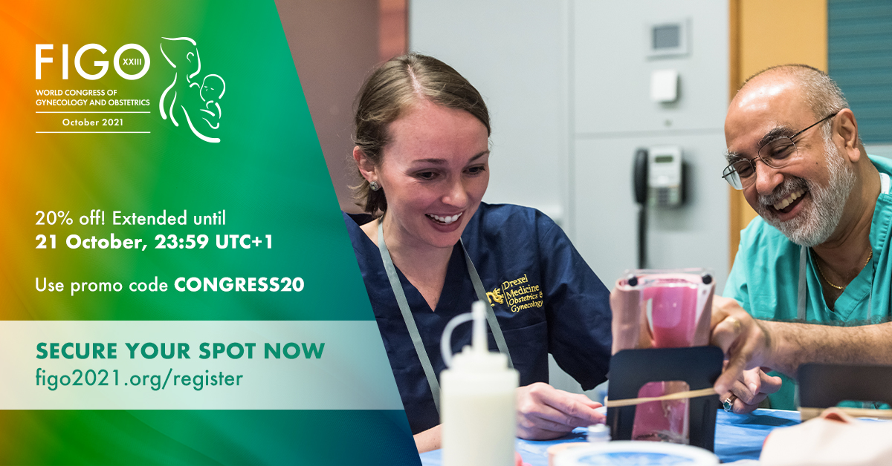

Dear colleagues,

The International Federation of Gynecology and Obstetrics have extended their offer for 20% off registration fees for the FIGO 2021 World Congress! Visit www.figo2021.org/register and use the code CONGRESS20 at checkout until 21 October, 23:59 UTC+1.

The FIGO World Congress, taking place online 21 – 28 October is soon approaching. FIGO is excited to welcome delegates from across the globe to learn, share and build alliances at the leading global event in gynaecology and obstetrics. You can find the full programme here.

Not yet registered? Don’t miss out on the opportunity to be a part of a global community at FIGO 2021. If you have any questions, please contact congress@figo.org.

